Class 4

# 3. Singular Value Decomposition



## 3.1 Introduction

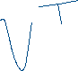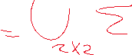

**Remark**

* The matrix is unique
* The matrix have the same size of , this mean can be rectangular

Several types of .



|  |  |  |
| --- | --- | --- |
|  |  |  |
|  |  |  |

|  |  |
| --- | --- |
|  |  |

## 3.2 Construction of the SVD

### 3.2.1

1. **Construct** 
   1. Determine the eigenvalues of .
   2. Order the eigenvalues such that and their respective eigenvectors.
   3. Normalize the eigenvectors.



* 1. **.**

1. **Construct**



* then

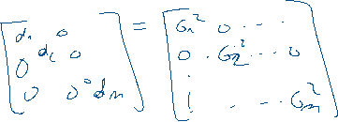

**.**

1. **Construct** 
   1. Determine



**.**



.

**3.2** If for every then:

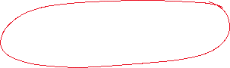

* is orthogonal ?

Remember :

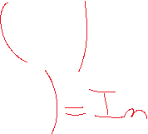

**See example with**

**-**

* 1. If for some , then:

**See example with**

**3.3.1** .

Suppose is the number , then has null columns.

* + 1. Choose the submatrix , constitute by the non null columns of .
    2. Find the subspace (orthogonal complement);
       1. Choose vectors in , such that .

The vectors and the columns of must be linearly independent.

**3.3.3.2** Using the Gram-Schmidt process find vectors such that is an orthonormal base.

**3.3.4**  **.**

### 3.2.2

**See example with**

1. **Construct** 
   1. Determine the eigenvalues of .
   2. Order the eigenvalues such that and their respective eigenvectors (.

* 1. Normalize the eigenvectors

1. **Construct**
2. **Construct** 
   1. Determine , if for some , then replace by .
   2. If for every then **.**
   3. If for some , then

**3.3.1**

Suppose is the number , then has null columns.

* + 1. Choose the submatrix , constitute by the non null columns of .
    2. Find the subspace (orthogonal complement).
       1. Choose vectors in , such that

The vectors and the columns of must be linearly independent.

**3.3.3.2** Using the Gram-Schmidt process find vectors such that is a orthonormal base.

**3.3. 4**

### 3.2.3

**See example with**

1. **Construct** 
   1. Determine the eigenvalues of .
   2. Order the eigenvalues such that and their respective eigenvectors.
   3. Normalize the eigenvectors.
2. **Construct**

. .

1. **Construct** 
   1. Determine , if for some , then replace by .

has at least null columns, suppose is the number of null columns.

* 1. Choose , the submatrix constitute by the non null columns of .
  2. Find the subspace (orthogonal complement).
     1. Choose vectors in , such that .

The vectors and the columns of must be linearly independent.

* + 1. Using the Gram-Schmidt process find vectors such that is a orthonormal base.



# 4. Matrix Approximation

Consider with the factorization with , and .

We construct a rank-1 matrix as

is the column of , and is the column of.

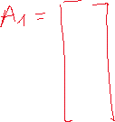

**Definition**



The matrix is called approximation of with



**Example**

|  |
| --- |
|  |
|  |

|  |  |
| --- | --- |
|  |  |
| Approximation with rank-10 matrix | Approximation with rank-20 matrix |
|  |  |
| Approximation with rank-30 matrix | Approximation with rank-50 matrix |

